C. SOP- Geographic Features for Samples

September 17th 2019 – Elizabeth Tray - Updated Sep 9th 2020

* *Major notes that need to be fixed by Adam as of sept 2020*
  + *Lough Bunaveela needs name updated*
  + *Burrishoole Catchment needs name updated*

# Assigning Features

1. There are 2 ways to assign features. Either in the
   1. special network of Burrishoole (because it has a very high sample output, and long term archive) or
   2. the default method, which is just any catchment where the sample was collected.
2. Also- we use nested sampling locations. Depending on known information, a sample can be assigned to various geographic levels. But the most precise location should be assigned. Then it can be found by the levels above it’s assignment. For example, if a sample is assigned to Lake Feeagh, then it can be found when searching Lake Feeagh, and it can be found when searching the Erriff-Clew Bay catchment.

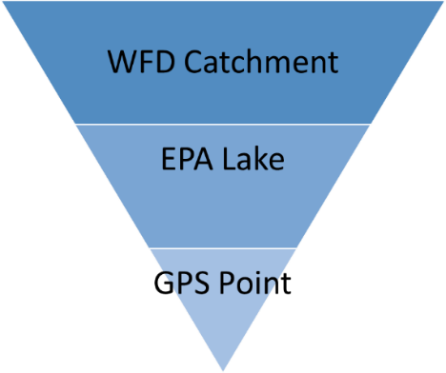

* 1. **For samples to the special network of the Burrishoole Catchment:**
     1. This network was created specifically for Burrishoole. There are 2 polygons for the lakes, 5 points for the individual traps. In addition, we can create a series of gps points if known, but this has happened yet. All of these have been nested inside the WFD sub catchment polygon, called ‘Burrishoole Catchment Area’, which is inside the ‘Erriff Clew Bay WFD Catchment Polygon’. Outlined below are the features samples can be attributed to:
     2. Erriff Clew Bay WFD Catchment Polygon
        1. Burrishoole Catchment Area WFD
           1. EPA Lough Furnace (id code: 52_506)
           2. EPA Lough Feeagh (id code: 52_510)
           3. Lough Bunaveela
           4. Marine Institute - Newport Salmon Leap and Mill Race Traps

Mill Race Upstream Trap

Salmon Leap Upstream Trap

Mill Race Downstream Trap

Salmon Leap Downstream Trap

Salmon Leap and Mill Race Traps

* + 1. See the below scheme to understand the Burrishoole Features. A diagram to demonstrate the active archive features currently within Drupal (September 2019).
    2. A lot of times samples will be found and it’s pretty clear they are Burrishoole samples, and then you should just put them in the Burrishoole catchment area.
    3. Often times the exact location of a sample is not written on the sample itself. Typically, a general reference will be listed, like ‘Feeagh’, which means Lake Feeagh. Sometimes the samples might just say Burrishoole. We have nested the features to account for ambiguity.



.

* 1. **For samples from anywhere else:**
     1. All samples outside of Burrishoole are attributed to a WFD catchment polygon. In addition, and when needed, ICES marine squares, EPA transitional water bodies, and cruise tracks may potentially be added to handle sampling locations. For right now, the archive can handle samples from internal waters. The current WFD in Drupal are:
        1. WFD Dunmanus-Bantry-Kenmare (id code:21)
           1. EPA Lough Currane (id code: 21_457)
        2. WFD Lee, Cork Harbour and Youghal Bay Catchment (id code:19)
        3. WFD Corrib Catchment (id code:30)
        4. WFD Galway Bay North Catchment (id code:31)
           1. EPA Ballynahinch (id code: 31_228)
        5. WFD Blackwater (Munster) Catchment (id code:18)
        6. WFD Lough Neagh & Lower Bann Catchment (id code: 03)
        7. WFD Boyne Catchment (id code:07)
        8. WFD Lower Shannon Catchment (id code:25D)
        9. WFD Moy & Killala Bay Catchment (id code:34)
           1. EPA Lough Conn (id code: 34_406b)
        10. WFD Erne Catchment (id code:36)

1. The above 2 lists have had Features added to them- see the below screenshots. They are current up to September 2020
   1. All of the catchments in IFBA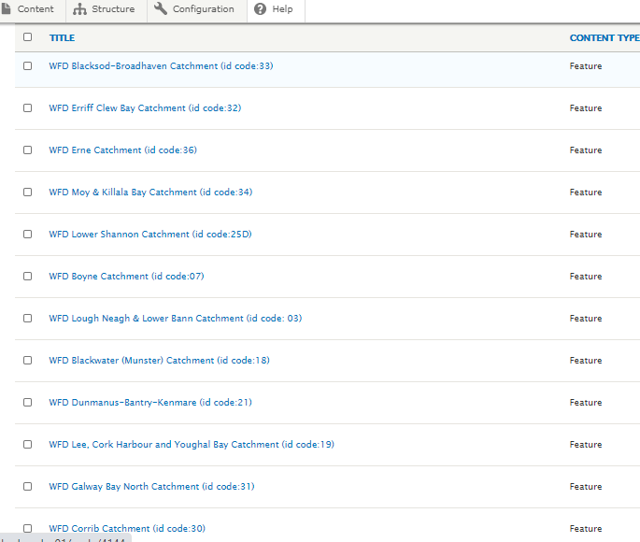
   2. All of the current sub catchments in IFBA (this name needs to be updated to look like the rest)- also it’s called the sarahmore catchment in the text file)

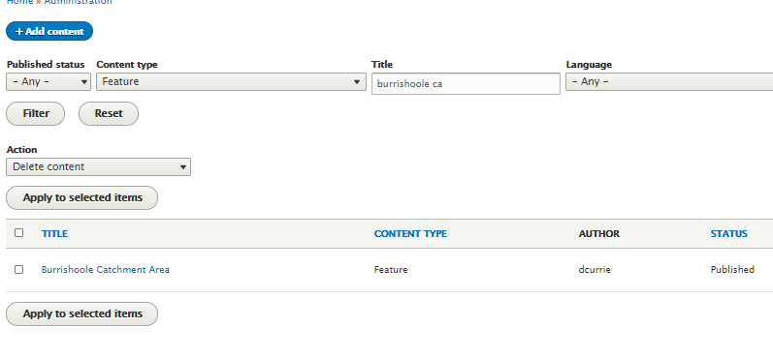

* 1. All of the current lakes in IFBA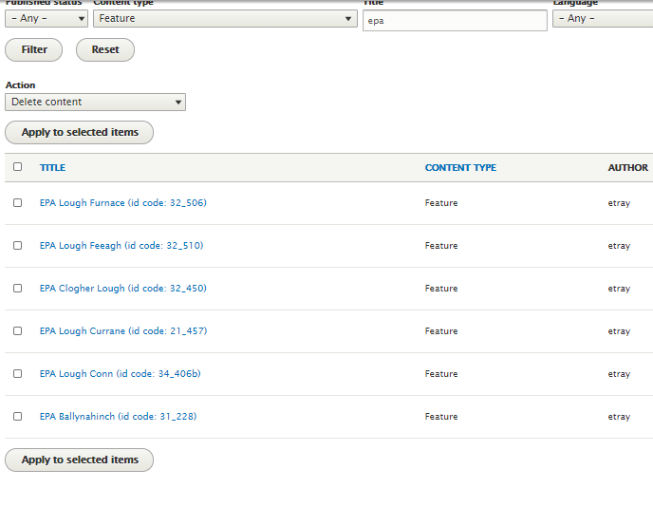
  2. All of the current traps in IFBA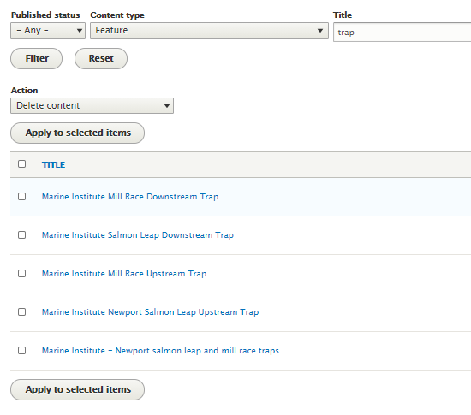
  3. All of the international points in IFBA

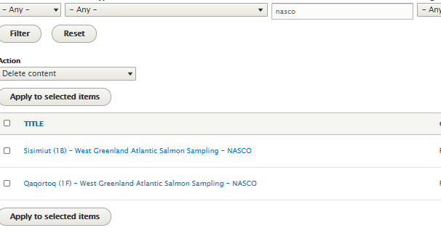

# Creating Features

1. You must know the feature you plan to assign the sample to prior to cataloguing. If the feature doesn’t exist it needs to be created by the Data Management Team in OSIS.
2. The Archive uses 2 main sources for geometry. The EPA’s WFD for Catchments, and the EPA for lakes. The polygon geometry for both the WFD catchments and the EPA lakes are in the folder called ‘Text files to create a feature in Drupal’. There is a 3rd folder in here, for sub catchments, but we don’t use the subcatchments, we just used one sub catchment polygon for the Burrishoole catchment because we have so much data from here it needed special representation. Here are the folder names.
   * 1. EPA Lake polygons
     2. EPA WFD Catchments
     3. EPA WFD Subcatchments
3. If you going to add one in, need to follow the same outline as one that is already within Drupal to remain consistent.
4. A researcher **must ensure that a feature does not already exist** prior to creating a new feature. Check the folder that says ‘Features already in Drupal’.
5. Features can only be deleted by Adam

Here is what adding in a catchment looks like

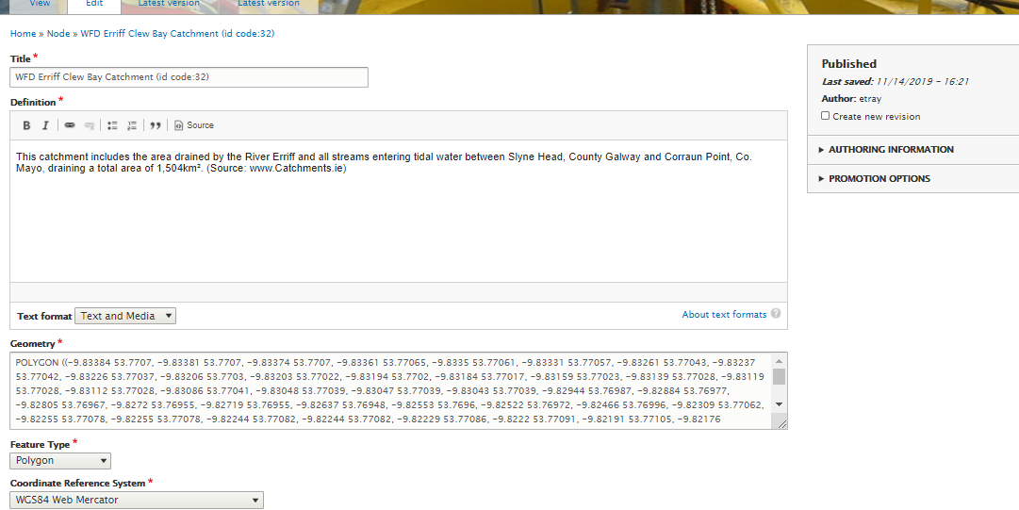

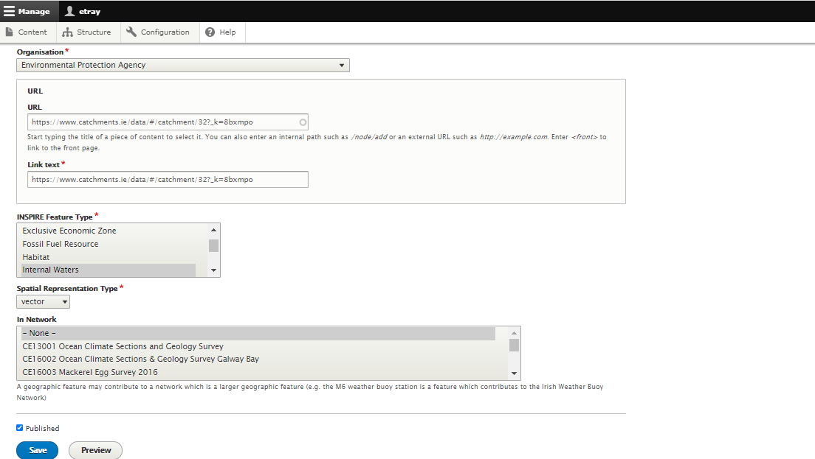

The front end of this feature looks like this